**Data Flow Diagrams:**

Project Design Phase-II

Data Flow Diagram & User Stories

|  |  |
| --- | --- |
| Date | 09 November 2022 |
| Team ID | PNT2022TMID51261 |
| Project Name | Real-Time River Water Quality  Monitoring and Control System |
| Maximum Marks | 4 Marks |

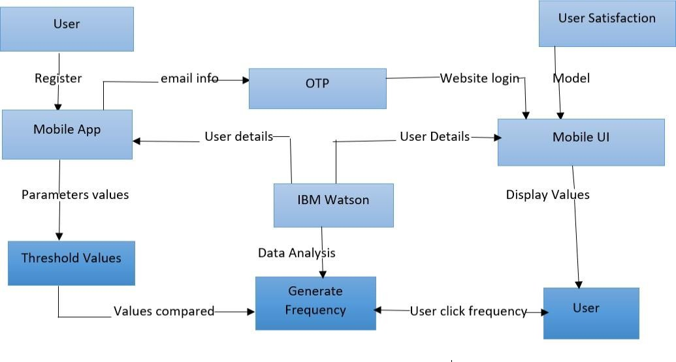

**User Stories**

Use the below template to list all the user stories for the product.

|  |  |  |  |  |  |  |
| --- | --- | --- | --- | --- | --- | --- |
| **User Type** | **Functional**  **Requirement (Epic)** | **User Story Number** | **User Story / Task** | **Acceptance criteria** | **Priority** | **Release** |
| Customer (Mobile user) | Registration | USN-1 | As a user, I can register for Mobile UI by entering my user details. | I can access my account / dashboard | High | Sprint-1 |
|  |  | USN-2 | As a user, I will receive OTP from email once I have registered for the Mobile App | I can receive OTP & Enter confirm | High | Sprint-1 |
|  |  | USN-3 | As a user, I can see the parameters in the mobile app UI | I can Analysis all the details | Medium | Sprint-2 |
|  |  | USN-4 | As a user, I can click the frequency to control the water quality |  | Medium | Sprint-1 |
|  | Login | USN-5 | As a user, I can monitor the water quality |  | High | Sprint-1 |
|  | Dashboard |  |  |  |  |  |
| Customer Care Executive | Via calling | USN | On calling company’s customer care center | Accepted by faster response | High | Sprint 4 |
| Administrator | Registration | USN | By personalized setting of products | Accepted | High | Sprint-3 |